Create a React Application “eventexamplesapp” to handle various events of the form elements in HTML.

1. Create “Increment” button to increase the value of the counter and “Decrement” button to decrease the value of the counter. The “Increase” button should invoke multiple methods.
   1. To increment the value
   2. 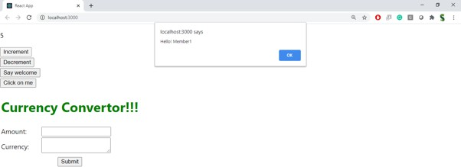Say Hello followed by a static message.
2. Create a button “Say Welcome” which invokes the function which takes “welcome” as an

argument.

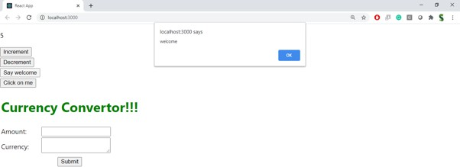

1. Create a button which invokes synthetic event “OnPress” which display “I was clicked”

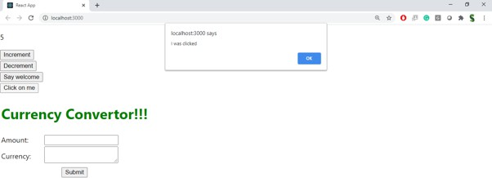

Create a “CurrencyConvertor” component which will convert the Indian Rupees to Euro when the Convert button is clicked.

Handle the Click event of the button to invoke the handleSubmit event and handle the conversion of the euro to rupees.

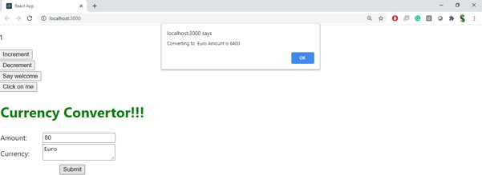

# EventExample.js

import React, { useState } from 'react'; function EventExample() {

const [count, setCount] = useState(0);

const increment = () => { setCount(prev => prev + 1);

};

const sayHello = () => {

console.log("Hello! Welcome to Event Handling in React");

};

const handleIncrement = () => { increment();

sayHello(); // multiple method call

};

const handleDecrement = () => { setCount(prev => prev - 1);

};

const sayWelcome = (message) => { alert(`Message: ${message}`);

};

const handleSyntheticEvent = (e) => { console.log("I was clicked");

};

return (

<div>

<h2>Event Examples</h2>

<p>Counter Value: {count}</p>

<button onClick={handleIncrement}>Increment</button>

<button onClick={handleDecrement}>Decrement</button>

<br /><br />

<button onClick={() => sayWelcome("Welcome!")}>Say Welcome</button>

<br /><br />

<button onClick={handleSyntheticEvent}>Synthetic Event Button</button>

</div>

);

}

export default EventExample;

# CurrencyConvertor.js

import React, { useState } from 'react'; function CurrencyConvertor() {

const [rupees, setRupees] = useState(''); const [euros, setEuros] = useState('');

const handleSubmit = (e) => { e.preventDefault();

const conversionRate = 0.011; // 1 INR ≈ 0.011 Euro

const result = (parseFloat(rupees) * conversionRate).toFixed(2); setEuros(result);

};

return (

<div style={{ marginTop: '30px' }}>

<h2>Currency Converter</h2>

<form onSubmit={handleSubmit}>

<label>Enter amount in INR:</label>

<input type="number" value={rupees}

onChange={(e) => setRupees(e.target.value)} placeholder="₹"

/>

<button type="submit">Convert</button>

</form>

{euros && <h3>Converted Amount: € {euros}</h3>}

</div>

);

}

export default CurrencyConvertor;

# App.js

import React from 'react'; import './App.css';

import EventExample from './EventExample';

import CurrencyConvertor from './CurrencyConvertor'; function App() {

return (

<div className="App">

<h1>Event Examples App</h1>

<EventExample />

<CurrencyConvertor />

</div>

);

}

export default App;

